**GENERATING UNIT IMPULSE AND UNIT STEP SEQUENCES**

**LAB # 07**



**CSE301L Signals & Systems Lab**

Submitted by: **Hamid Ur Rehman**

Registration No: **20PWCSE1969**

Class Section: **C**

“On my honor, as a student of University of Engineering and Technology, I have neither given nor received unauthorized assistance on this academic work.”

Student Signature: ______________

Submitted to: **Engr. Durr-e-Nayab**

June 12, 2022

**Department of Computer Systems Engineering**

**University of Engineering and Technology, Peshawar**

**Lab Objectives:**

Objectives of this lab are as follows:

* Generating unit impulse and unit step sequences.
* Basic signal operations.

**Task # 1:**

Using ones function, plot the signum sequence over interval ‐10≤n≤10. It can be defined as:

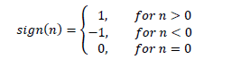

**Problem Analysis:**

Use ones and zeros functions to obtain the given signal.

**Code:**

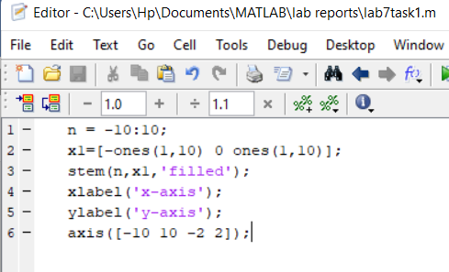

**Output:**

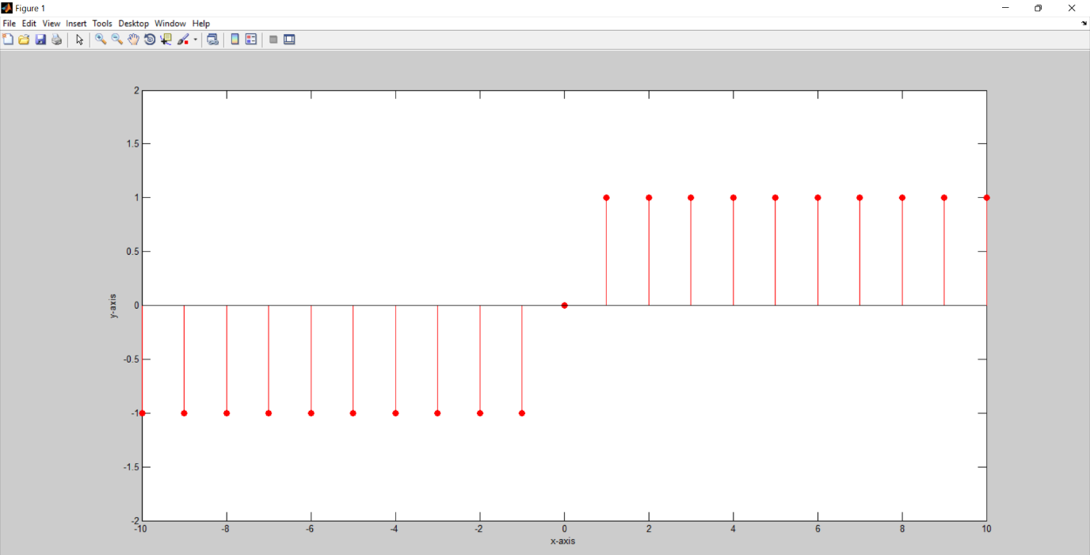

**Task # 2:**

Prove the following:



**Problem Analysis:**

To prove the given equation first generate a unit step signal and then subtract a shifted unit step signal from it.

**Code:**

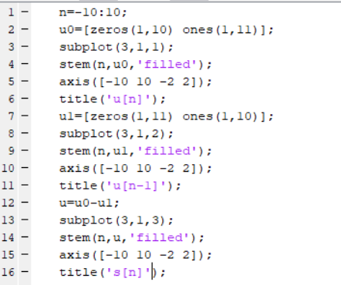

**Output:**

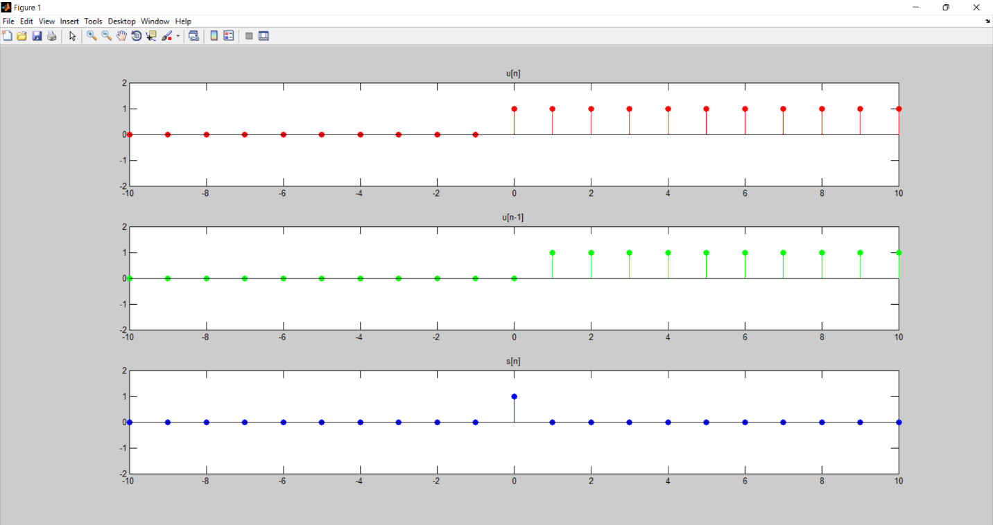

**Task # 3:**

Delay the original signal given in above example by 1 sec. Plot both the delayed & original signal on the same figure.

**Problem Analysis:**

To delay the signal by one unit, add one to the x-axis of the signal.

**Code:**

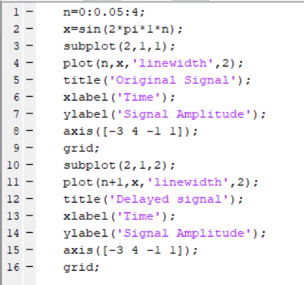

**Output:**

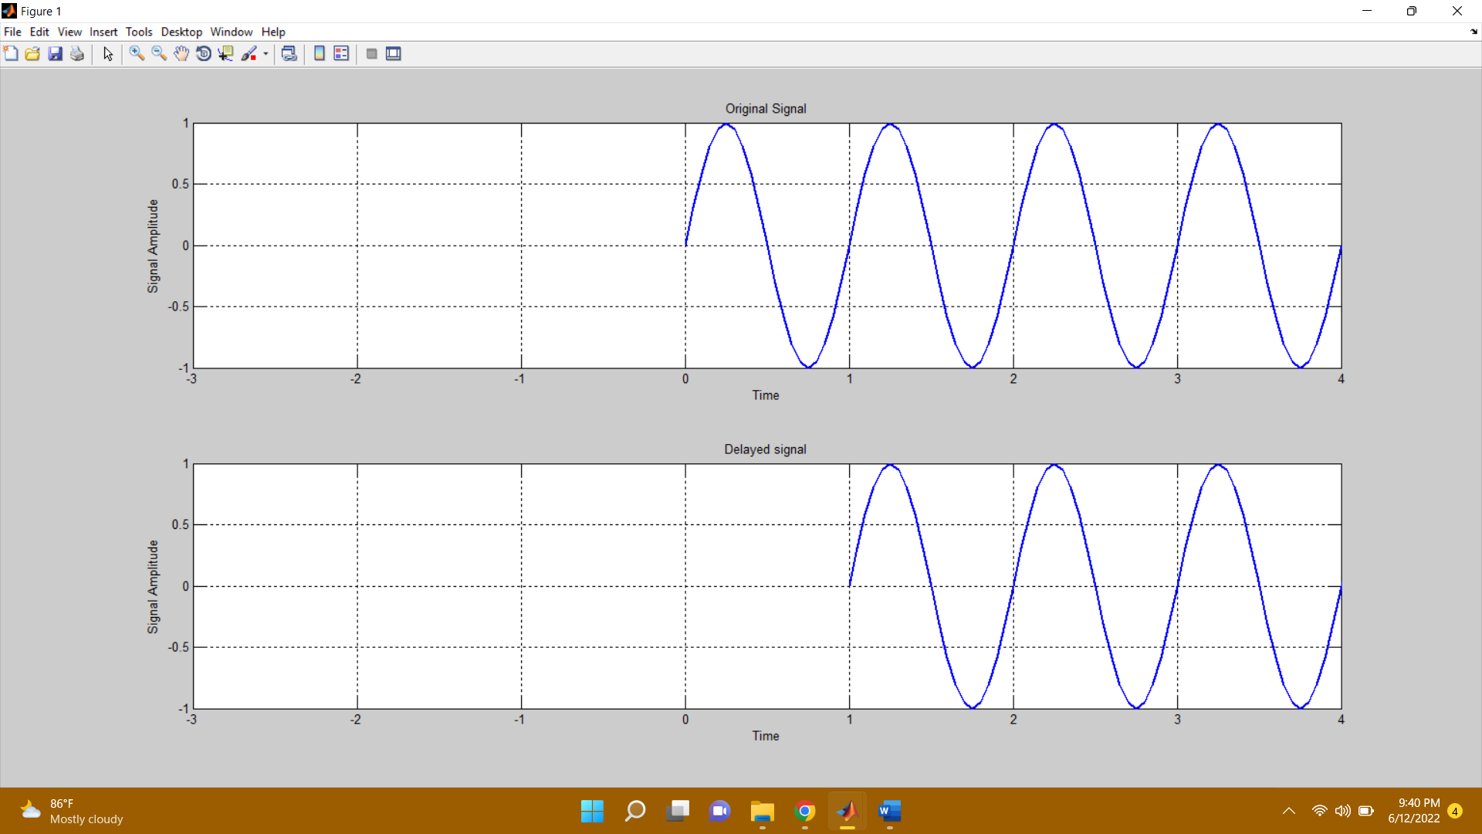

**Task # 4:**

Flip the following signal:



Plot the original signal as well as the flipped one in the same figure.

**Problem Analysis:**

To flip the given signal, multiply the x-axis of the signal to by minus.

**Code:**

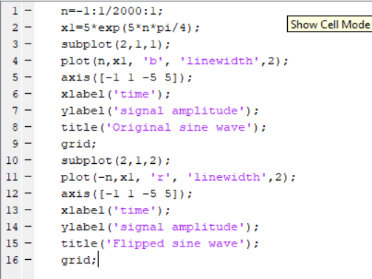

**Output:**

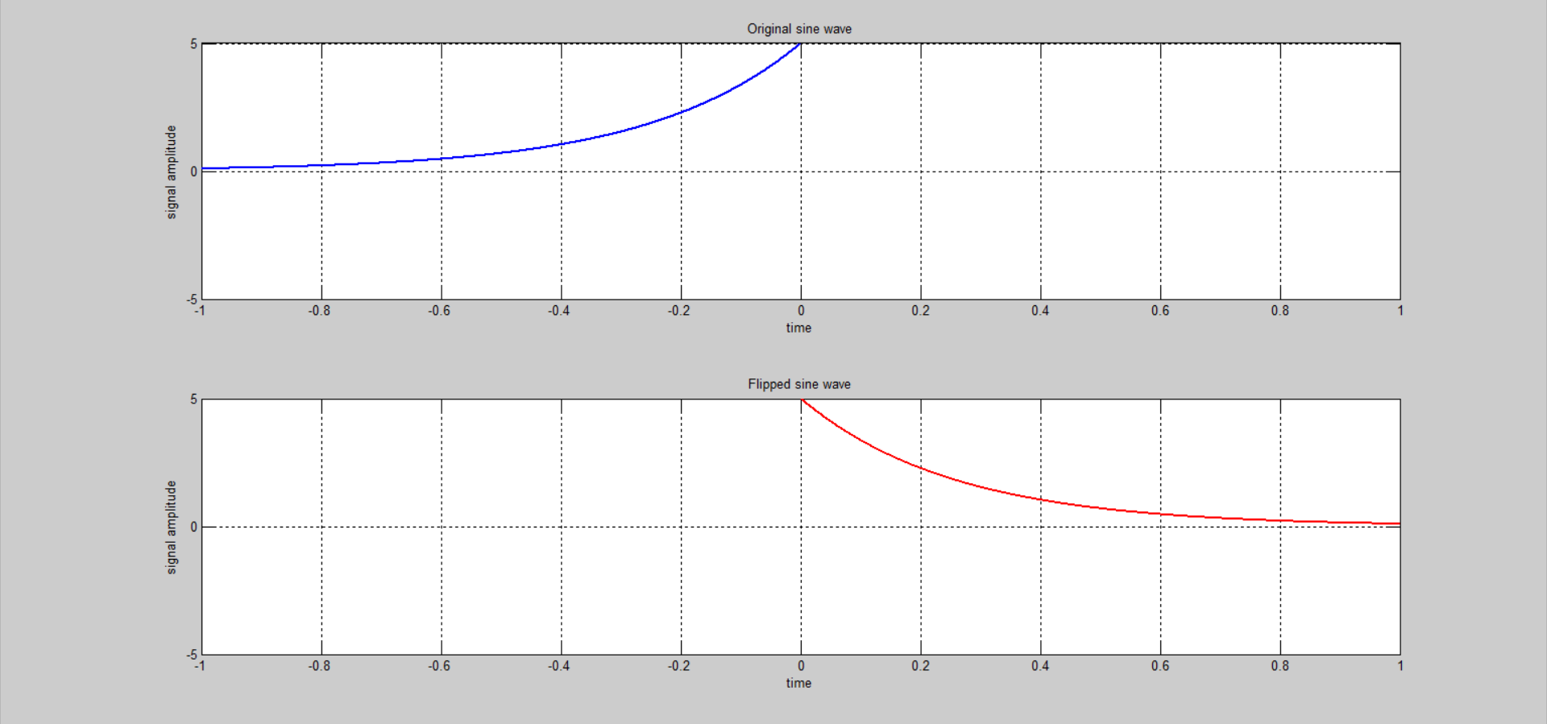

**Task # 5:**

Flip the following signal:

x[n]= 2δ[n]+ 5δ[n‐1] + 8δ[n‐2] + 4δ[n‐3] + 3δ[n‐4]

Plot the original signal as well as the flipped one in the same figure.

**Problem Analysis:**

Generate the signal as described above and then flip it.

**Code:**

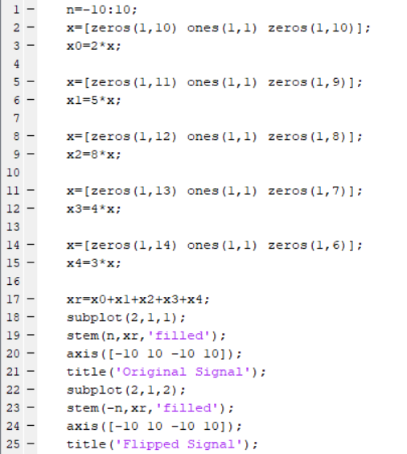

**Output:**

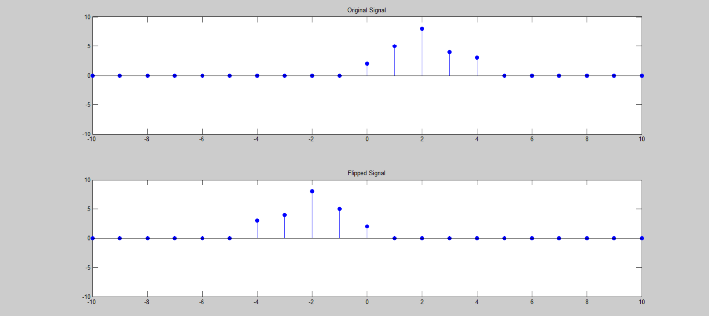

**Task # 6:**

Scale the continuous‐time sinusoid used in the signal shifting example by a factor of 2.

**Problem Analysis:**

To scale the amplitude of the signal, multiply the y-axis of the signal by the given factor.

**Code:**

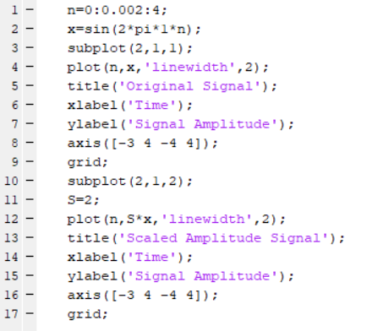

**Output:**

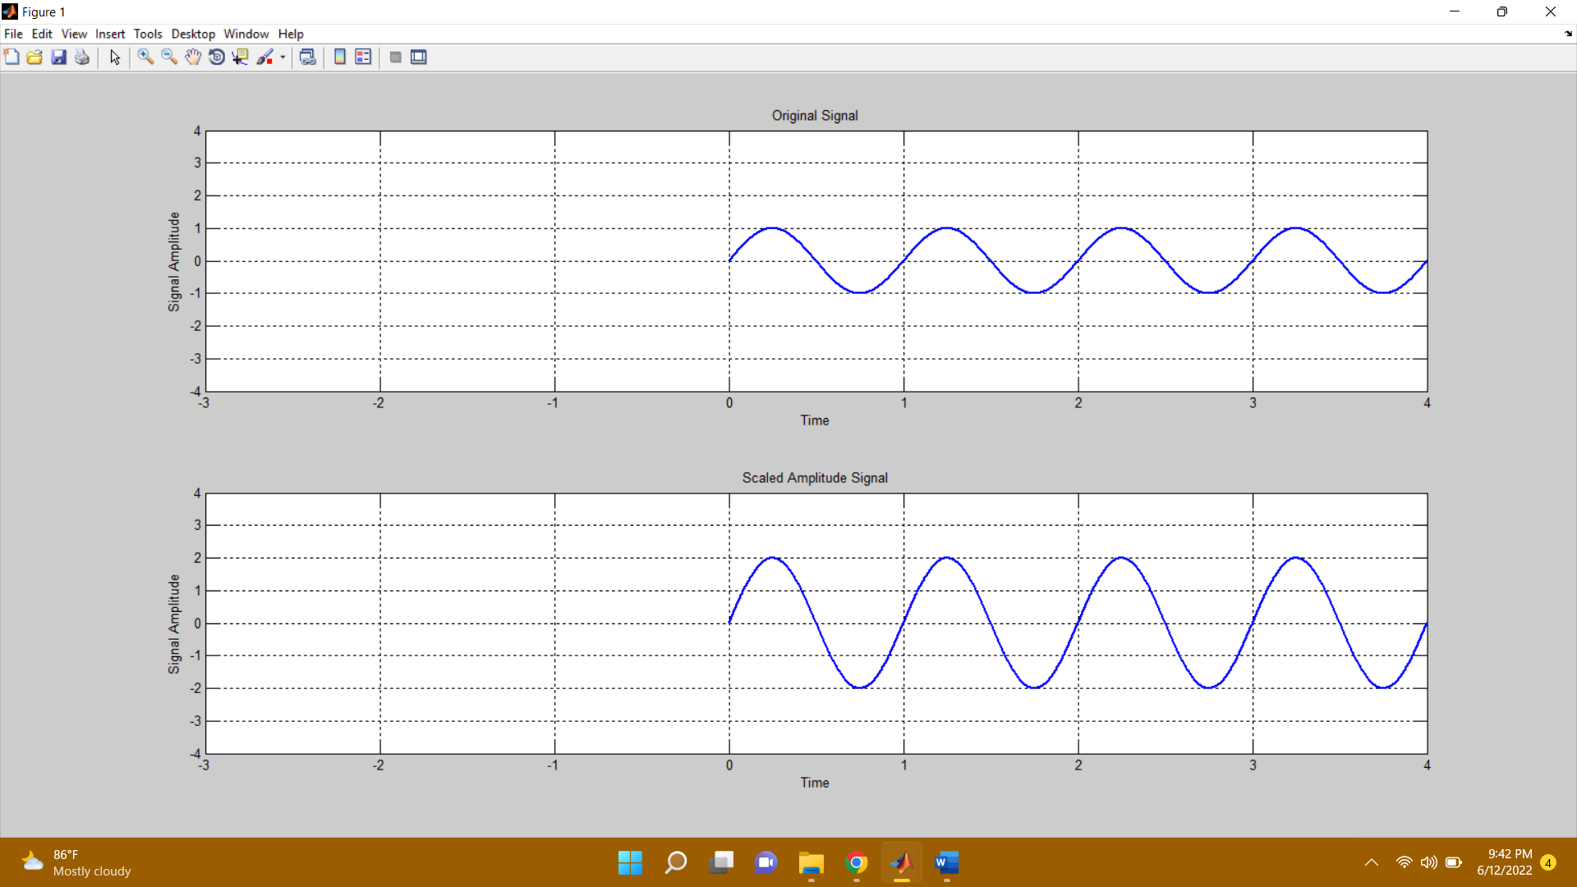

**Task # 7:**

Interpolate (up‐sample) the signal by a factor of 2.

**Problem Analysis:**

To interpolate the given signal use interp command.

**Code:**

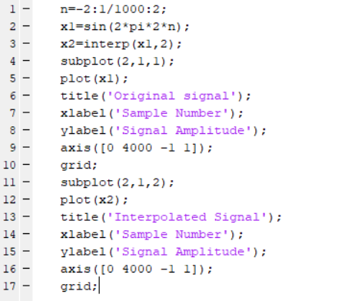

**Output:**

